Welcome to Historic Downtown Lapeer, Michigan

Historic Downtown Lapeer, is the heart of Lapeer County. It is located off of the I-69 international trade corridor in Michigan’s thumb region. With its small town charm and rich history it could be just the place you’ve been looking for.

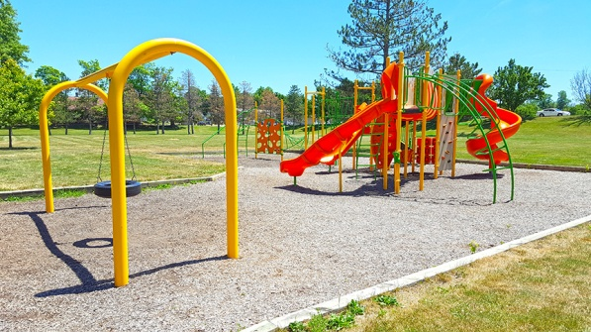
Why Choose Downtown Lapeer?
- Downtown Lapeer is a pedestrian friendly downtown, including walking paths, bike trails, and a large public park system.
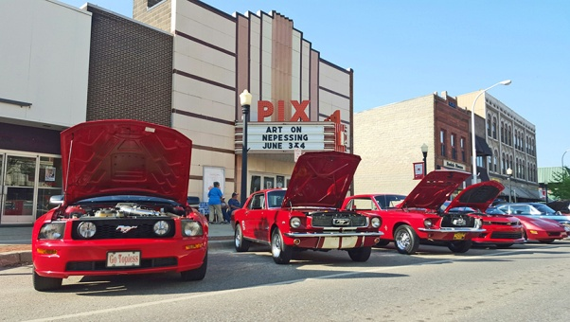
- Our annual Downtown events include the annual Art on Nepessing St. art fair, the Historic Farmers Market of Lapeer, the Lapeer Cruise, Summer Concert Series, Lapeer Days – Michigan’s largest FREE festival, Halloween Treat Walk, Winterfest, and more!
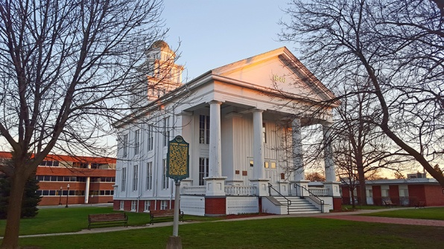
- The Center for the Arts of Greater Lapeer which includes Gallery 194 and the Historic PIX Theatre. The center hosts live theatre, concerts, art classes, theatre workshops, and art exhibits from local, national, and international artists.
- The Lapeer County Heritage Museum, home of the Lapeer County Historical Society and the Lapeer County Genealogy Society Research Center.
- Downtown Lapeer is home to Michigan’s oldest continuously operating courthouse and one of the 10 oldest in the country.
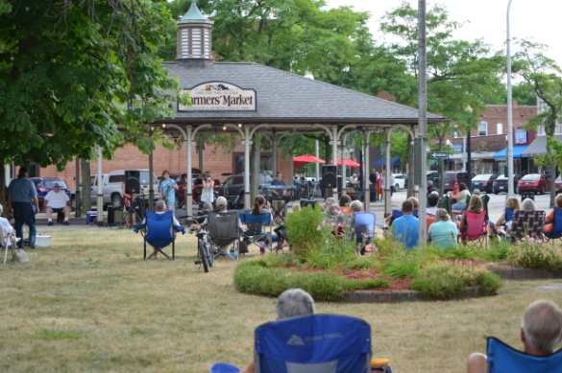
- Downtown Lapeer is home to the Marguerite de Angeli Library and a short distance away from Mott Community College, and Lapeer High School and athletic facilities.
- Plenty of free parking that allows easy access to restaurants, shopping, and services.
Learn More
James Alt Executive Director – Lapeer DDA
810-728-6598 - www.downtownlapeer.com
www.michiganmainstreetcenter.com

